2016 Conference

Ottawa

18 - 19 October 2016

Call for Abstracts

Health Promotion Ontario provides a forum for students, practitioners and researchers to come together and discuss issues and ideas in and around the field of health promotion. This year’s conference will be in celebration of the 30th anniversary of the Ottawa Charter for Health Promotion. To focus on discussing where the profession should head in the next 30 years, we will focus on the theme of what it means to be “Pushing Boundaries” in our practice. We will be exploring the importance of political, sectoral, disciplinary, methodological, institutional, and personal actions. What are the consequences of being risk averse? Accordingly, we are inviting presenters from various fields with diverse perspectives, to present work that enacts the strategies and actions of the Ottawa Charter and helps us to look to the future.

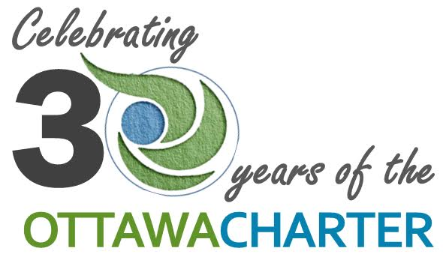

ABSTRACT SUBMISSION
Abstracts must be submitted via e-mail to: ketan.shankardass@gmail.com and mandy.vaiya@peelregion.ca as an attachment in MS Word format, including a title, list of authors (under the presenting author), unit or department where the work was carried out, and funding support (where appropriate) at the end of the abstract. Abstracts must be no more than 500 words in length. Please indicate the research & practice theme(s) most relevant to your abstract at the end of your submission. Please also indicate the type of presentation you would like to deliver.
RESEARCH & PRACTICE THEMES

We are seeking submissions around strategies and actions of the Ottawa Charter for Health Promotion, specifically as they pertain to “pushing boundaries” in the field – in practice and research.

Strategies  - Advocate  - Enable  - Mediate | Actions  - Building healthy public policy  - Creating supportive environments  - Strengthening community action  - Developing personal skills  - Reorienting health care services toward  prevention and health promotion
http://www.phac-aspc.gc.ca/ph-sp/docs/charter-chartre/pdf/charter.pdf

TYPES OF PRESENTATIONS

90 Minute Workshop
Format description: Workshops will be 90 minutes in length including time for discussion and questions, and will allow for a presenter or team of presenters to provide skill development, professional development, or a more in-depth presentation relevant to the research or practice themes seen below. The format must be interactive and allow a significant amount of audience participation.

Poster Presentation
Format description: Accepted posters with similar themes will be grouped together, and an author will be asked to present a 5 minute summary of their poster. Poster presentations will take place on October 19, 2016.

15 Minute Research Presentation
Format description: A concurrent session will consist of no more than four different concurrent presentations each being 15 minutes maximum. It is recommended that concurrent presentations include a maximum of two presenters, through additional team members may be available to respond. Presentations should focus on the research and practice themes seen below.

DEADLINE FOR ABSTRACT SUBMISSION: Extended ~ Sept. 8th, 2016

Notice: You will receive notice of acceptance within 4 weeks of submission.

HPO is unable to cover the costs of registration for presenters. Presenters are required to pay for their own registration for HPO Conference.

