2016 Conference

Health Promotion Ontario Conference

OTTAWA
18-19
OCTOBER
2016

Health Promotion Ontario provides a forum for students, practitioners and researchers to come together and discuss issues and ideas in and around the field of health promotion. This year’s conference will be in celebration of the 30th anniversary of the Ottawa Charter for Health Promotion. To reflect on remaining challenges and discuss where the profession should head in the next 30 years, we will focus on the theme of what it means to be “Pushing Boundaries” in our practice. We will be exploring the importance of political, sectoral, disciplinary, methodological, institutional, and personal actions. What are the consequences of being risk averse? Accordingly, we are inviting presenters with diverse perspectives to present work that enacts the strategies and actions of the Ottawa Charter and helps us to look to the future.

Conference Theme

Canadian Museum of Nature
240 McLeod Street
Ottawa Ontario K2P 2R1
Canada

Conference Venue

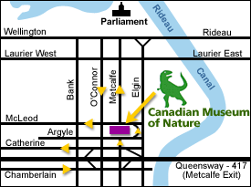
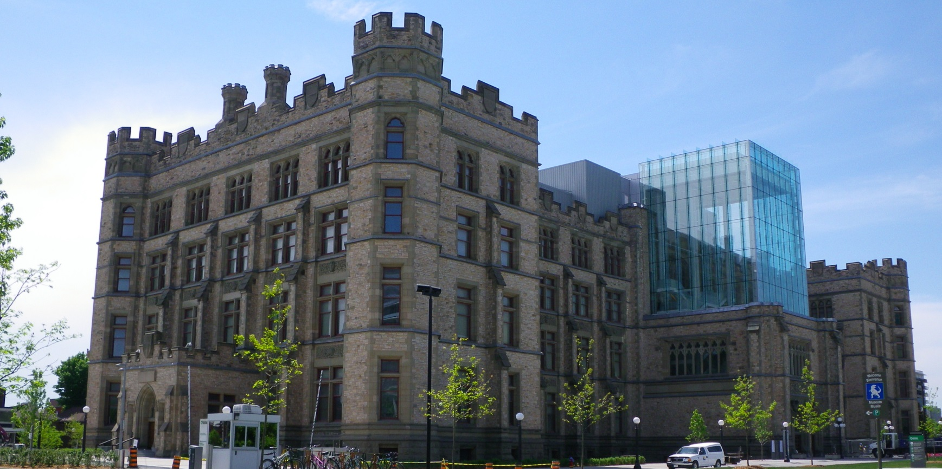
Conference Cost
Early Bird Registration*
Member $ 170.00
Non-Member $ 195.00
Student $ 120.00
Regular Registration
Member $ 200.00
Non-Member $ 225.00
Student $ 140.00

*Early Bird Registration has limited spaces and it is on a first come first serve basis.
Please note that in total only 160 registrations spots are available for the conference

Conference Program
Day 1 – October 18
1:00 pm | Conference Registration
1:45 pm | Welcome Remarks
2:00 pm | Kick-off Panel with Q & A: Celebrating 30 years of the Ottawa Charter: Past, Present and Future
2:45 pm | Refreshment Break
3:00 pm | Moderated Discussion: Climate change and the Canadian diet- future of health promotion
5:00 pm | Evening Reception

Day 2 – October 19
8:00 am | Conference Registration
9:00 am | Welcome Remarks
9:15 am | Opening Keynote
10:15 am | Stretching Break
10:30 am | Workshops
12:00 pm | Lunch & Young Professionals Networking Event
1:30 pm | Abstract Presentations
2:30 pm | Closing Keynote
3:15 pm | Concluding Remarks

